Programming Contest Contestants
Thank you all for your patience as we sorted out some last-minute details with CodeChef. The practice site is
https://www.codechef.com/PACE22TS
The sample programming practice problem is available via the above link.

If you already have a CodeChef login, please click on the login button. If you have not signed up for CodeChef, please create an account by clicking the here link.

If you create a new login you will need to fill in the form with information, similar to the one below.
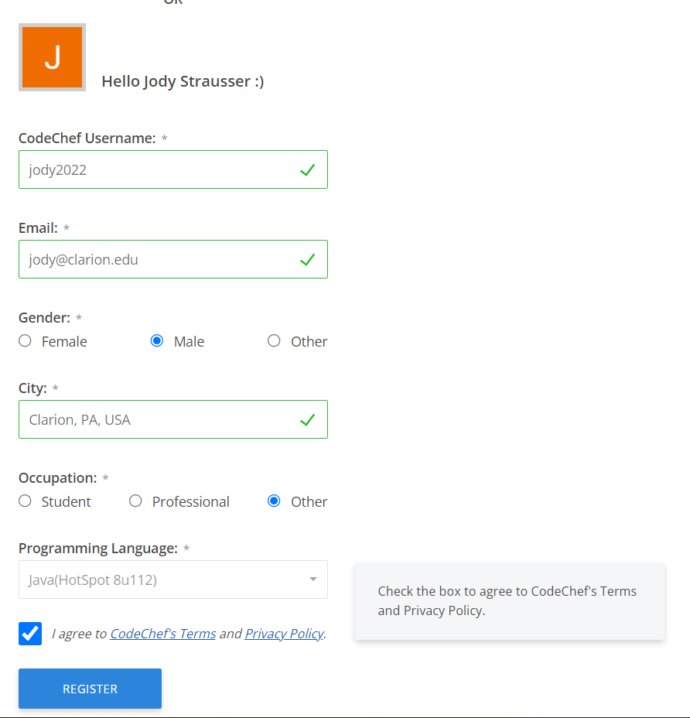

If all went well, you should see the message below.
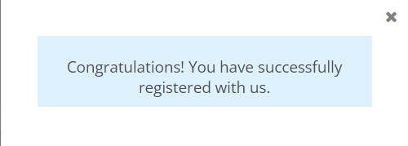

Next, click on the link to the test site again: https://www.codechef.com/PACE22TS
While you shouldn’t be required to register for the TEST site, I do recommend that you click on the REGISTER button. On the actual contest site, it is a requirement.
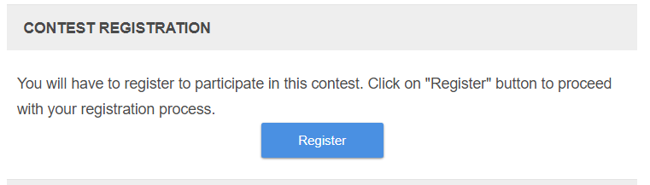

Click the registration button. You will be taken to a screen like the one below.
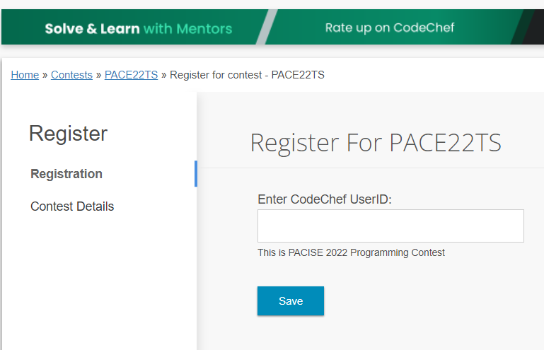

Type in your CodeChef username. Most of you will need to do this on the actual contest page as well.
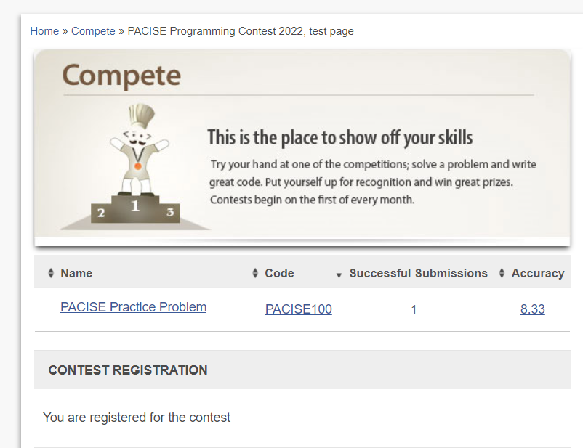
Once registered for the Practice Problem contest you will see a page similar to the one below.

Click on the link to the PACISE Practice Problem. Read the problem carefully. When you are ready to start coding, click on the blue Submit button.

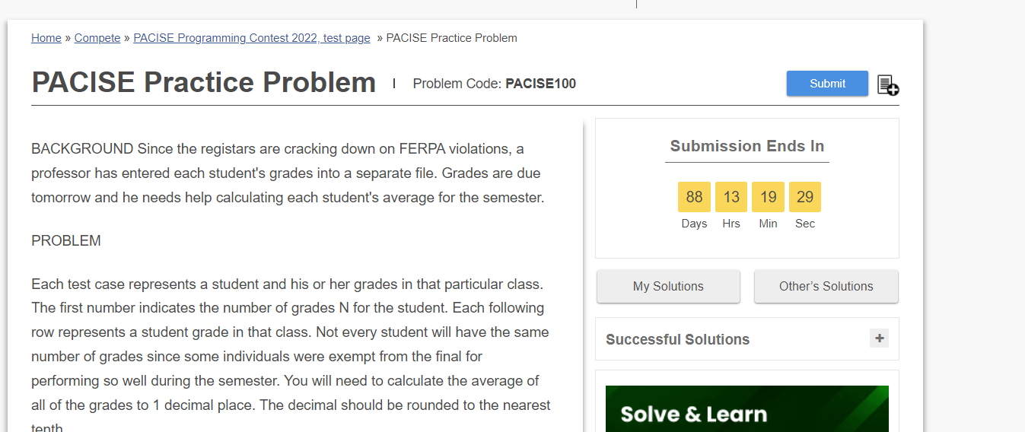
You will then be taken to the IDE portion of the site where you will write your code.

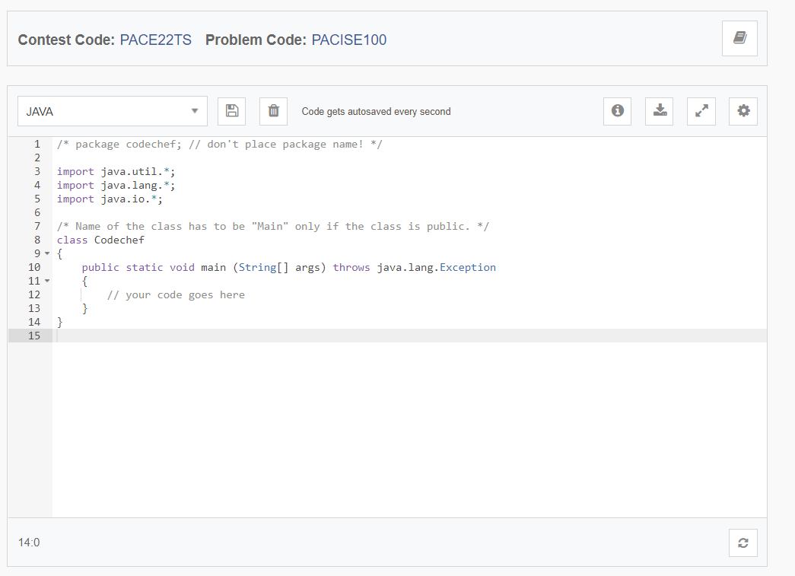

Once you have all of your code written, you can type in your own test data and click the Run button if you would like. If you prefer to test your solution against the test data, press the Submit button. The latter is a longer process, so it is recommended that you use the sample test data first and only submit it when you have the sample data working. That being said, you can submit your code to run against the test data up to 500 times.
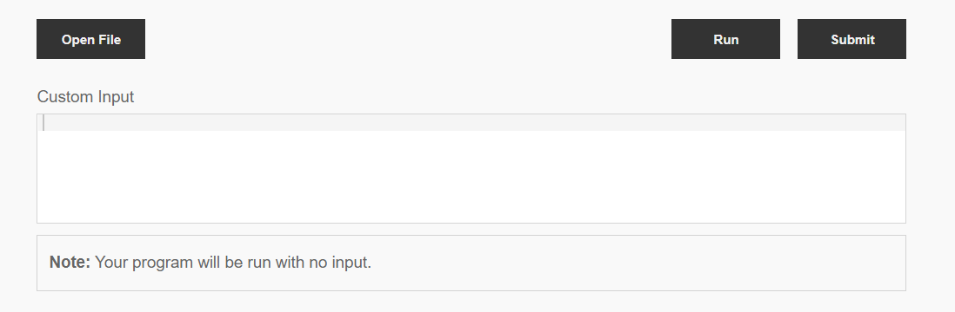

If your code did not work, you will get an error located above the IDE similar to the ones below.

You may click on the errors and number to view more information about your error and view the stdout and stderr messages.
A green message indicator with the word Success written in it will appear when you have submitted the problem successfully.

The Programming contest chair, Jody Strausser, will be available via Zoom via the zoom link https://clarion.zoom.us/j/91674344327 from 8:00 PM to 9:00 PM to assist as much as possible should you run into issues. You can also email him at jstrausser@clarion.edu.

