Programming Contest Competition Instructions
Thank you all for your patience as we sorted out some last-minute details with CodeChef. The practice site is
https://www.codechef.com/PACE2022
The sample ACTUAL practice problems become available via the above link at the start of the competition.
If you completed the Practice Session, you should already have a CodeChef login, please click on the login button and simply need to login to the CodeChef website.
Registration
You are required to register for the COMPETITION site.
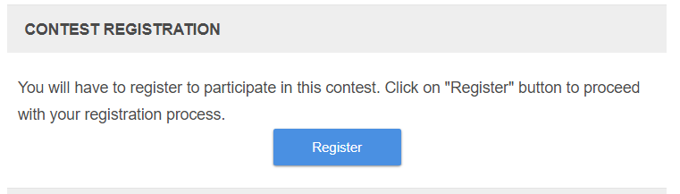

Click the registration button. You will be taken to a screen like the one below. I believe those of you who sent your CodeChef IDs during the registration process, should already have access. If you don’t see a countdown clock, it means you need to register for the competition.
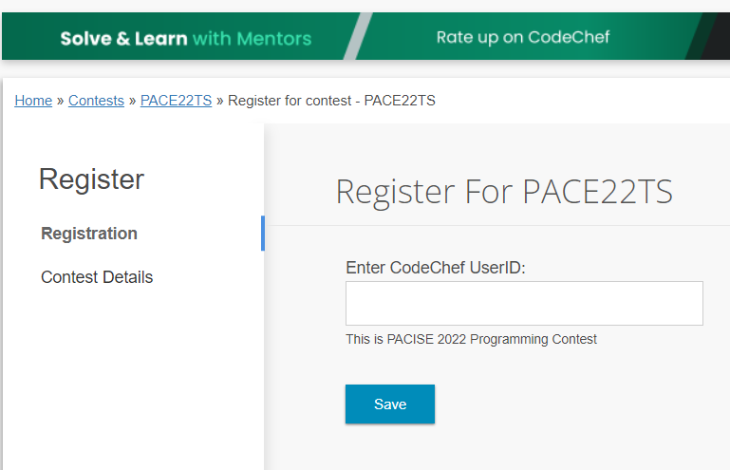

Type in your CodeChef username. Those of you that signed
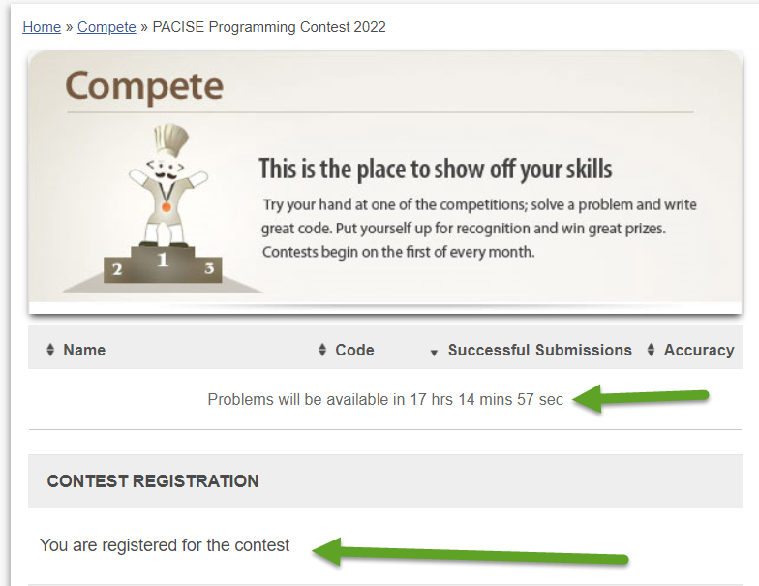
Once registered for the Practice Problem contest you will see a page similar to the one below.

Click on the link to the PACISE Practice Problem. Read the problem carefully. When you are ready to start coding, click on the blue Submit button. (Note the images below are taken from the practice problem, not the contest site).

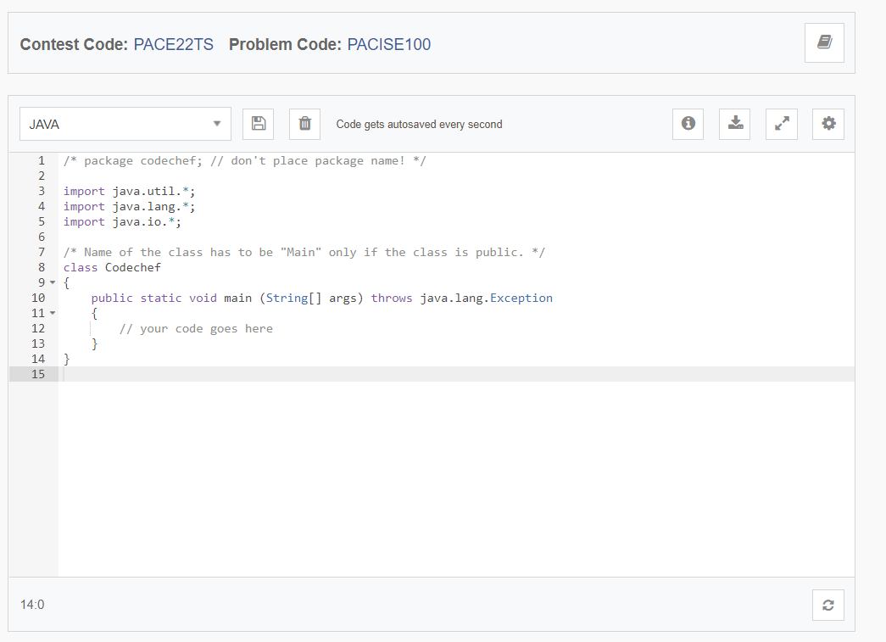
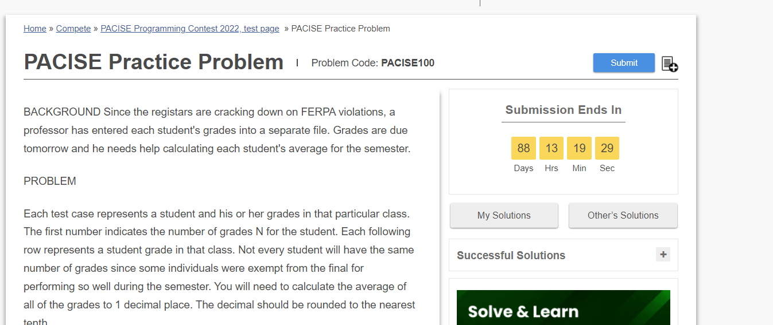
You will then be taken to the IDE portion of the site where you will write your code.

Once you have all of your code written, you can type in your own test data and click the Run button if your would like. If you prefer to test your solution against the test data, press the Submit button. The latter is a longer process, so it is recommended that you use the sample test data first and only submit when you have the sample data working. That being said, you can submit your code to run against the test data up to 500 times.
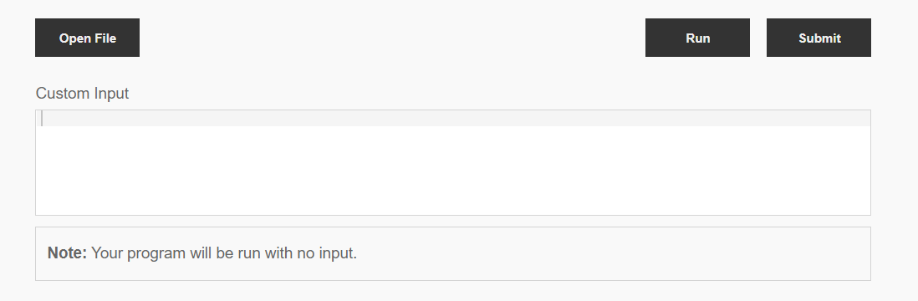

If your code did not work, you will get an error located above the IDE similar to the ones below.

You may click on the errors and number to view more information about your error and view the stdout and stderr messages.
A green message indicator with the word Success written in it will appear when you have submitted the problem successfully.

The Programming contest chair, Jody Strausser, will be available via Zoom from 10:00AM to 2:00PM to answer any clarification questions via the zoom link https://clarion.zoom.us/j/91674344327. You can also email him at jstrausser@clarion.edu.

